School Management ERP
User Manual
School Management ERP (Enterprise Resource Planning) is a complete web application and collection of programs designed to assist schools in administering their executive responsibilities on a day-to-day basis. Also it operates your school with much more advantages than a traditional school.
This school management system empowers schools to keep track of their daily operations while centralizing their resources and information. This managing system helps to reduce the pressure of managing a large amount of data from the school.

It includes the user's full journey to every school or educational institution from student admission to student leaving, from fee collection to exam results.
More than 10+ major modules with 7 inbuilt users (Super Admin, Admin, Accountant, Teacher, Librarian, Parent, and Student) panel. Moreover, it has a robust reporting system for all modules.

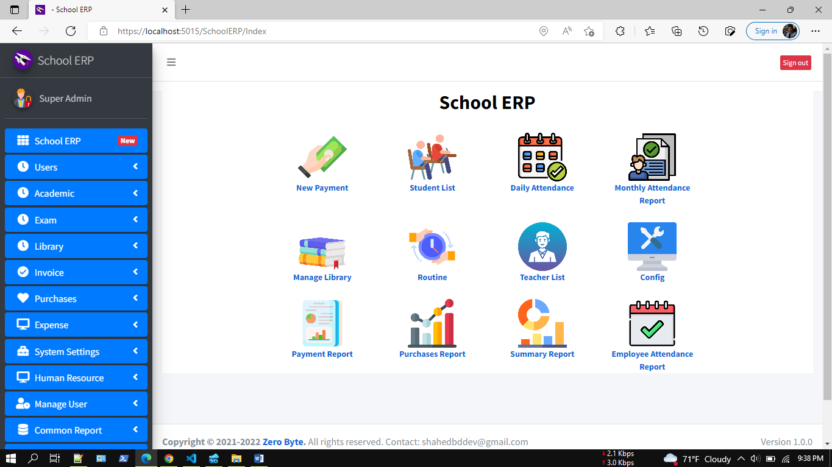

Core Feature
Student Payment
Superfast invoice generation and print invoices with multiple options will definitely add another dimension to your business. Also, you can share invoices through email instantly.

Attendance
In this school management ERP, super admin, admin, and teacher can take students' attendance to track academic progress.

Class routine
The class routine is another part of academic terms in school management ERP. The super admin and admin create the class routine for different classes. In this panel, class routine helps to complete regular academic activities.

Subject
In this school management, the subject is a part of academic activities. Students, teachers, and parents have permission to overview subjects. Only super admin and admin can add different subjects for different classes.

Syllabus
The syllabus is another essential part of academic activities in school management ERP. The syllabus supports other educational activities, such as class routine, subject, and department. In this panel, the super admin, admin, and teacher have permission to create the syllabus for the students, and only parents and students have permission to view the syllabus.

Class
In this term, super admin and admin can create a class to operate other's regular academic activities. They can also create sections, edit, and delete if they need. Classes and sections help to run class routine, subject, syllabus, classroom, and department.

Classroom
The classroom is a significant part of operating academic activities in an educational institute. Only admin and super admin can add, edit and remove classrooms, and they have an essential role in making a proper layout for the institute.

Department
Every educational institute has different departments to function for academic progress. In school management ERP, super admin and admin have the authority to add, edit, and erase various departments.

Event calendar
The academic calendar is an essential part of this term. It helps to make track of an academic session. Everyone can see the event and detail from this panel. In school management ERP, super admin and admin can add an event to the academic calendar.

Library Management
Library management systems help libraries keep track of the books, their checkouts, and members' subscriptions and profiles.

Student Promotion
Student promotion by the student or by class with proper status.

Expense
Organization all-expense you can manage using this application. Have multiple reports to track company expenses properly.

Purchase
You can track all of your purchase histories using this application so quickly. This module automatically adjusts the newly added items into your inventory. Have multiple reports to visualize the entire purchase module.

Dashboard
Dynamic dashboard with recent registered student and recent payment items.

Reports
Get comprehensive insights into your business with 20+ detailed reports designed for you. Overview & item stock, product quantity and damage item, general profit and/or loss report, sales, purchases, customer, suppliers and staff user reports.

Currency Exchange
Easily accept any Currency Denomination While making a Sale or Return.

Custom Receipts
Easily customize your receipts to match what you need for your business. There are 5 different configuration options for making your receipts how you want them.

Admin LTE Theme:
Use the excellent and responsive theme in a low ambient light environment to reduce eyestrain. It provides a range of responsive, reusable, and commonly used components.

Settings
Easily manage the app with settings for logo, categories, variants, currencies, custom page access, and identity option.

Much more
User login history, user management, email configuration, nice UI.

Technical Features
- ASP.NET Core 5.0
- EF Core code first
- Identity Core
- MSSQL/MySQL
- Partial page update CRUD operation
- Razor and jQuery for FE
- jQuery DataTable for faster data load
- Sweet Alert2 and Toaster notification
- select2 dropdown
- ASP.NET Core MVC Architecture
- Swagger for API documentation
- Dependency Injection
- Standard Naming conventions
- JWT Token Based Authentication and Claim Based Authorization
- All Methods are Async/Await
- CORS Settings
- Docker Support

Technologies:
Microsoft Visual Studio Community 2019 or later, ASP.NET Core 5.0, Identity Core, Entity Framework Code First, MSSQL SERVER 2017/MySQL, AdminLTE 3.0.5, JavaScript, jQuery data table, bootstrap 4, sweetalert, toastr, Fontawesome etc.

Prerequisite Application:
Microsoft Visual Studio Community 2019 or later, .Net Core 5.0, MS SQL SERVER 2017/MySQL, IIS, Chrome/Edge Browser.

How to run this Project:
Step 1:
Unzip the downloaded zip folder (SchoolMS.zip)
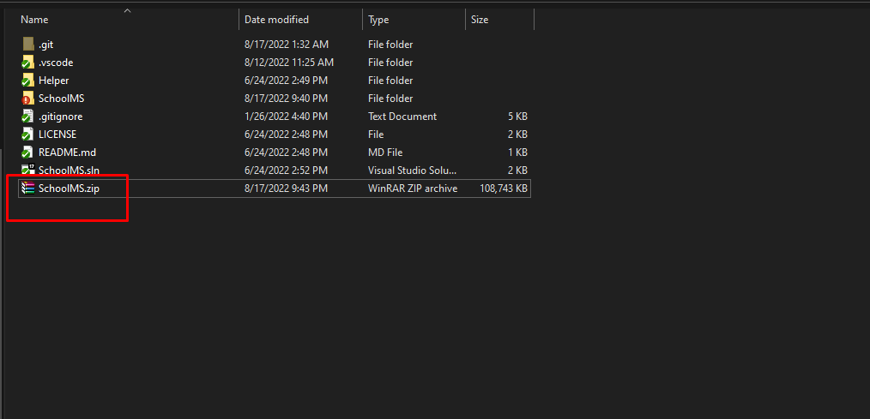

Step 2:
Open SchoolMS.sln file with Visual Studio 2019/2022/VS Code
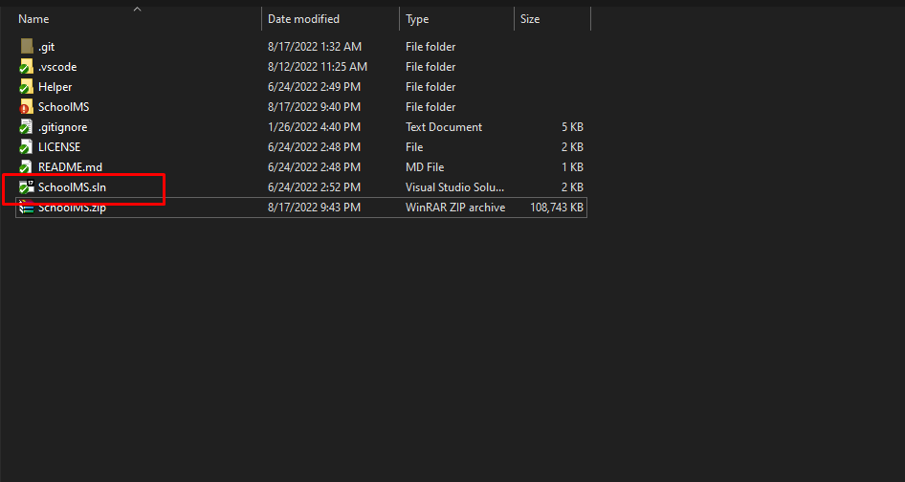
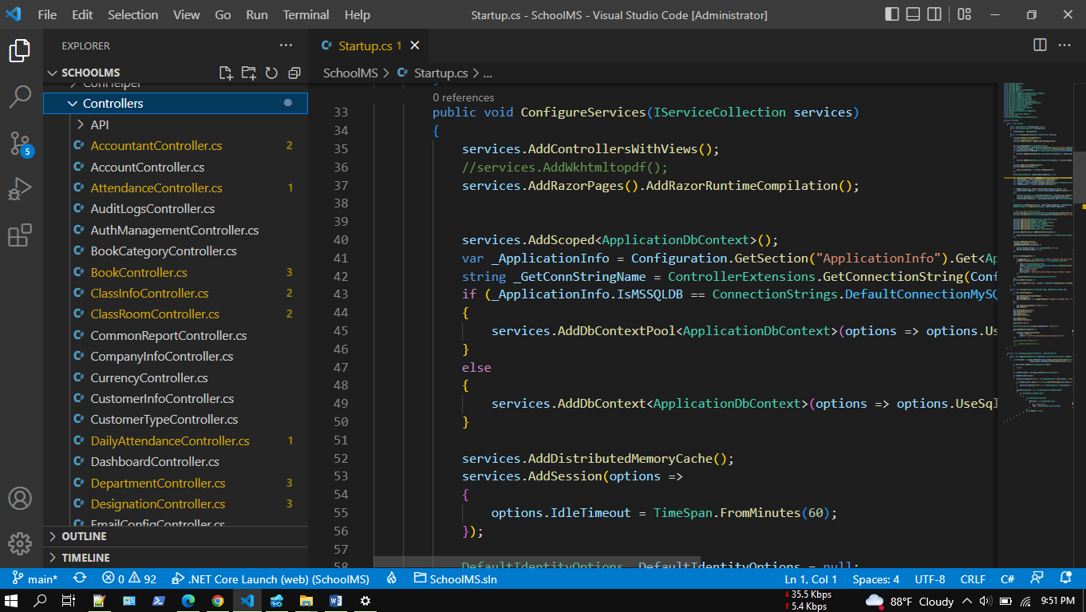

Step 3:
Update database connection: appsettings.json
“DefaultConnection”: “Server=DEVSTATION\\MSSQLSERVER2017; Database= SchoolMS;User ID=sa;Password=dev123456”
Server=Your MSSQL Server Name
User ID= Your MSSQL Server User Name
Password= Your MSSQL Server User Password
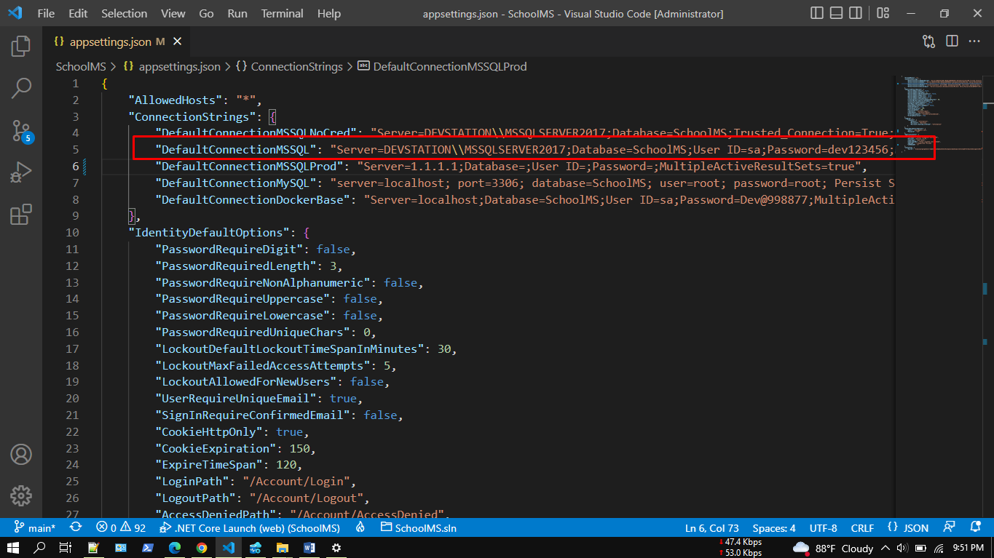

DB Notes:
public const int DefaultConnectionMSSQLNoCred = 0;
public const int DefaultConnectionMSSQL = 1;
public const int DefaultConnectionMySQL = 2;
public const int DefaultConnectionDockerBase = 3;
public const int DefaultConnectionMSSQLProd = 4;
public const int DefaultConnectionOthers = 5;
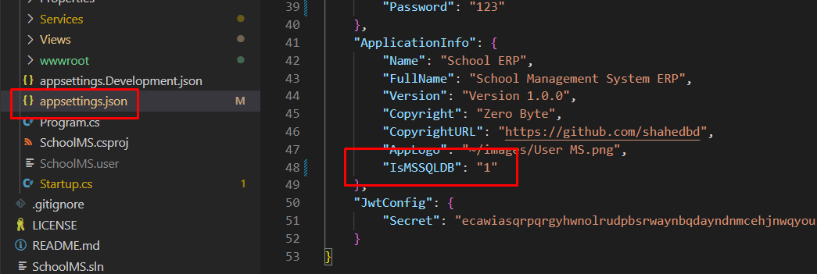

Step 4:
No need to create new migration rule and update database. You just need to build and run the application. Already initial migration rule included with project. Please make sure MS SQL server running properly.
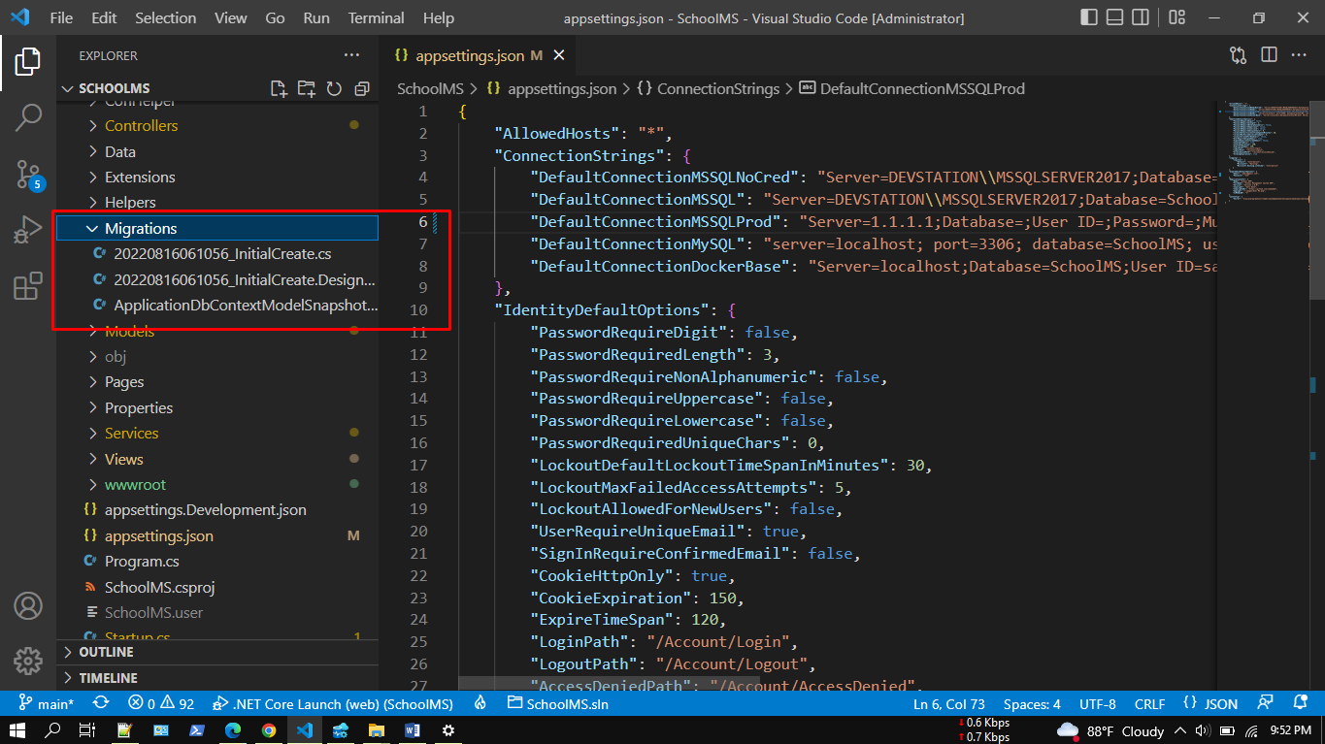

Step 5:
5.1: Build application by pressing f6
5.2: Run application by pressing f5
https://localhost:5015/Account/Login
User Name: admin@gmail.com
Password: 123

Swagger:
http://localhost:5014/swagger/index.html

Initially in the SQL server, relevant tables and data will be created in the database dynamically as code first approach.

Step 6:
Browse full application.
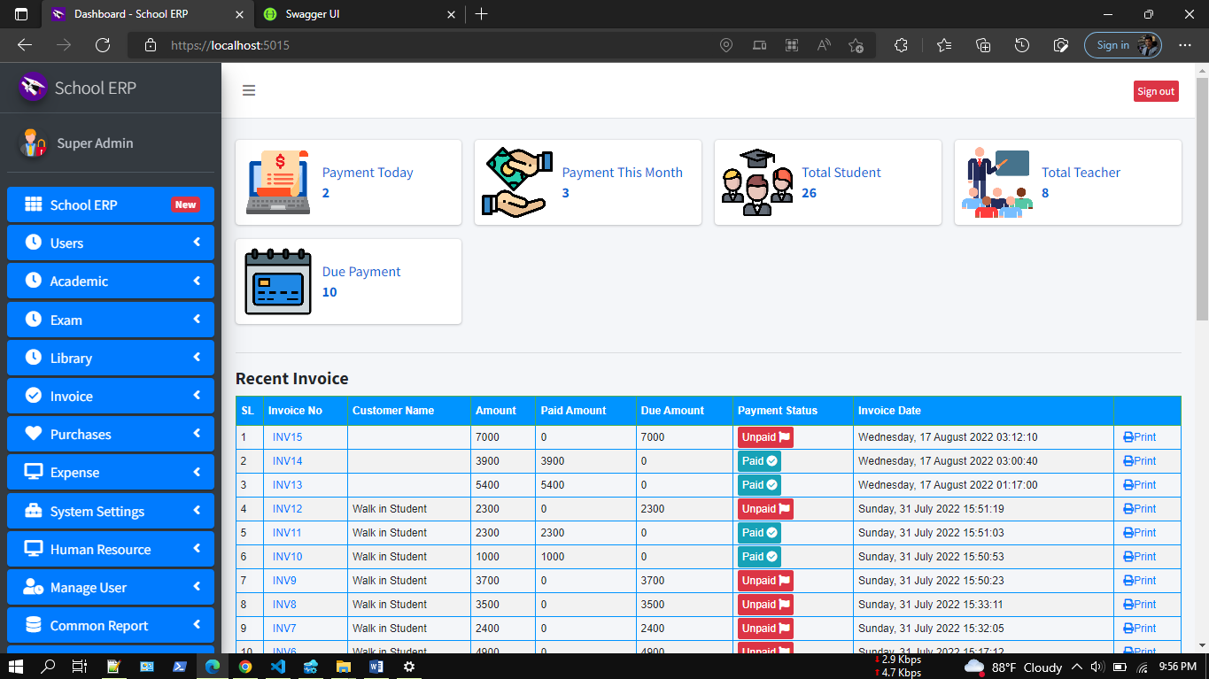
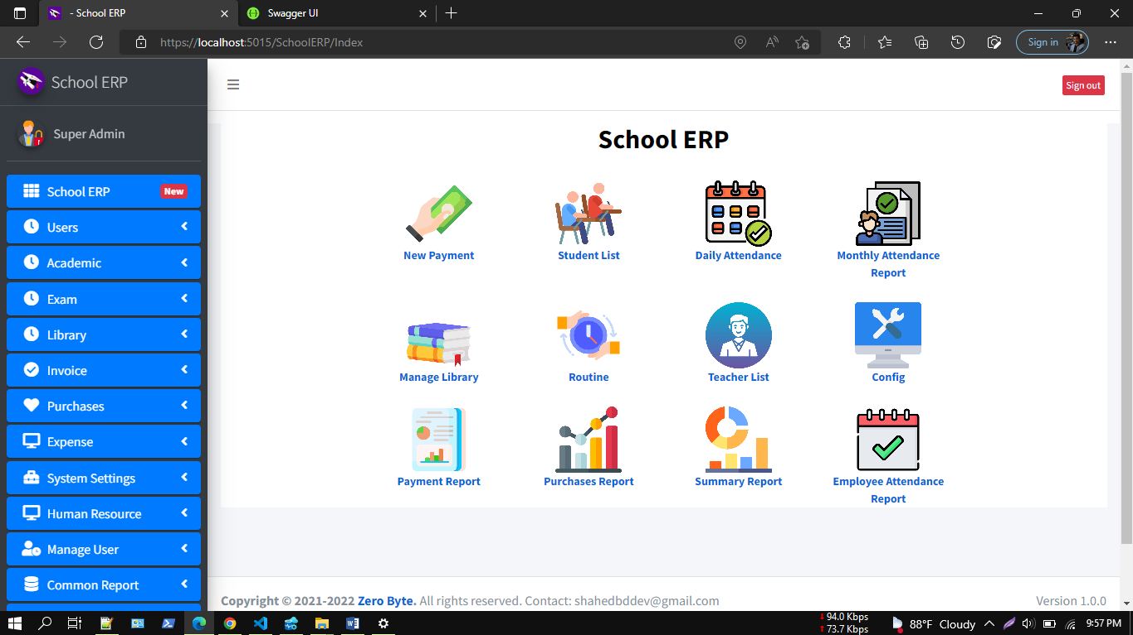

Summary Report:
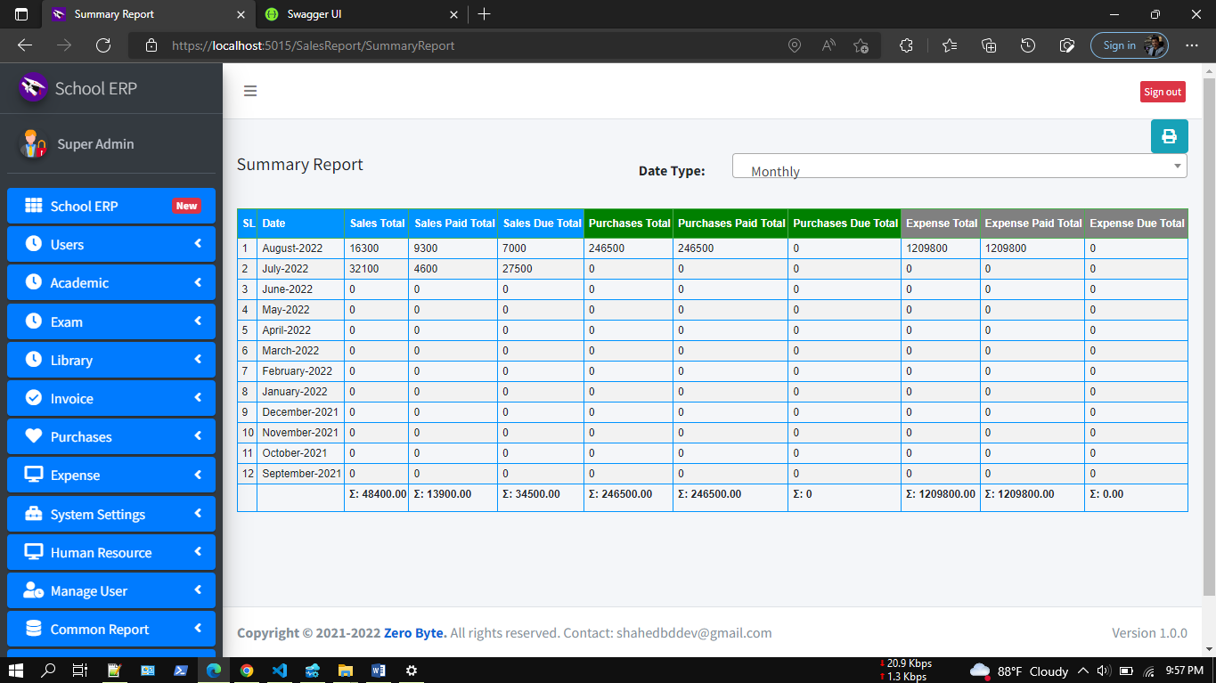
Monthly Attendance Report
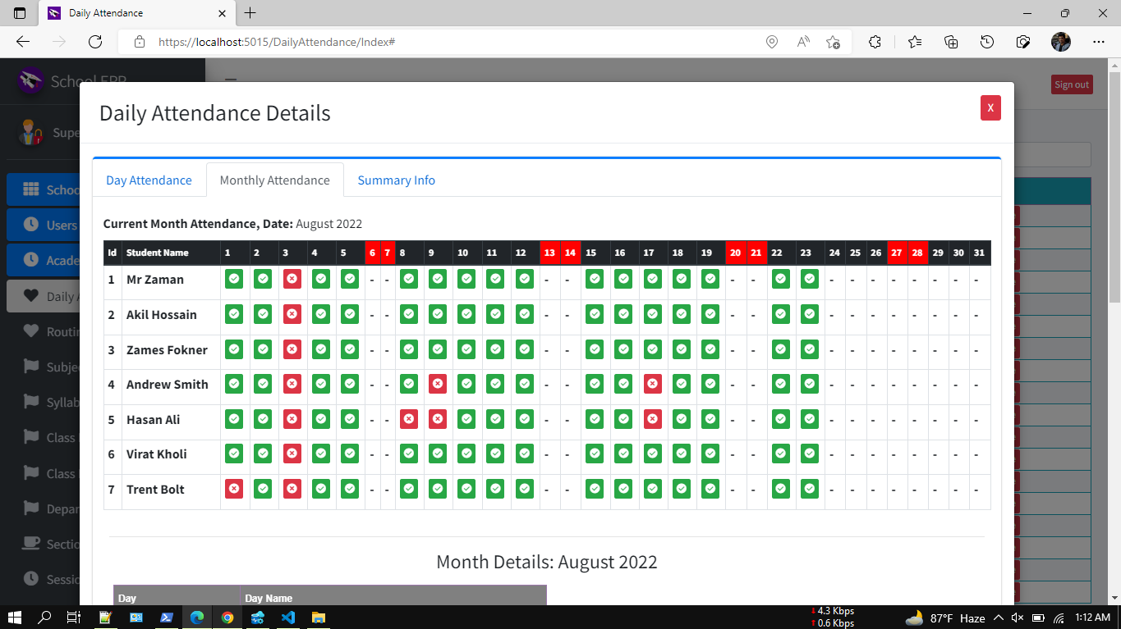

Current Student
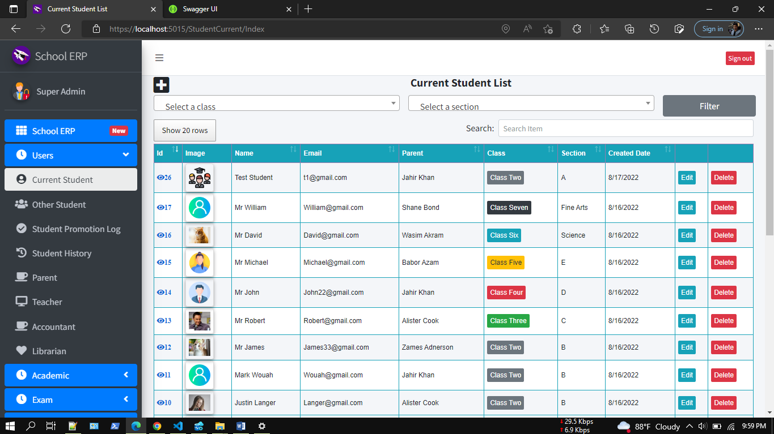

Demo Video:
Attendance
https://youtu.be/9y1JrbW03KQ
Librarian:
https://youtu.be/_NV-A6Q8h5k
Full School ERP:
https://www.youtube.com/watch?v=NH7w2AplexM

App Screenshot:
https://photos.app.goo.gl/s4pshtsbmGVPVSAA7

DB Migration:
Tools--> Nuget Package Manager--> Package Manager Console

PM> add-migration initcreate
PM> update-database

Check .Net Version:
Press Windows + R.
Type cmd.
On the command prompt, type dotnet --version

FAQ:
Question: How to install Database/How to run migration/Database table not creating?
Answer: Please follow these steps,
1. Make sure the right database connection is in the appsettings.json file
2. Check your server name, by running this SQL: SELECT @@SERVERNAME AS 'Server Name'
3. Delete the database from your SQL Management Studio (if already created)
4. Just build the project (As we have already included Migrations in the project)
5. Run the project
6. Now check your DB. Hopefully, DB and all tables you will find now.
Please cross-check, Program.cs and appsettings.json files properly.

appsettings.json
"DefaultConnectionMSSQL": "Server=DEVSTATION\\MSSQLSERVER2017;Database=WebStarterKit;User ID=sa;Password=dev123456;MultipleActiveResultSets=true",
Note that,
Server = your local server
Database = any name
User ID=your local MSSQL Server user name
Password=your local MSSQL Server user password

Required Application:
- Visual Studio 2022
- MSSQ 2017/later
- Dotnet SDK 6.0

Our Product:
SL | Product
1 | Advance POS System with Stock Manager | ASP.NET Core | EF Core | .NET Core 6.0
2 | Asset Management System with Barcode | ASP.NET Core | EF Core | .NET Core 6.0
3 | Hospital and Pharmacy Management System | ASP.NET Core | EF Core
4 | ASP.NET Core full CRUD with .NET 5 | MSSQL/MySQL | EF code first
5 | Inventory and User Management System
6 | Invoice Gen(Invoice Generation and Management) using .Net Core and EF
7 | Complaint | Issue | Helpdesk Ticket | My Ticket HelpDesk Support System | ASP.NET Core | EF Core
8 | Advanced Files & Users Management | ASP.NET Core | EF Core | .NET Core | MSSQL | MySQL
9 | User Management
10 | Business ERP Solution/Product/POS/Company Management
11 | School/College/University Management ERP
12 | ASP.NET Core CRUD Operation Using Dot Net 6.0 | MVC| MSSQL | MySQL | EF Core Code First | jQuery

Tutorials Video:
How to deploy/host ASP.NET Core 6.0 MVC App to IIS Using VS Code | Visual Studio
How to Install Microsoft SQL Server 2019 and SSMS on Windows 10 | Windows 11| Step By Step

Our YouTube Channel

Supports:
If you want to modify or add new features, or any technical issues you have faced during installation you can always contact us at, shahedbddev@gmail.com
WhatsApp: 8801674411603
Telegram: shahed71bd
Skype: shahedatomap
Email: shahedbddev@gmail.com

